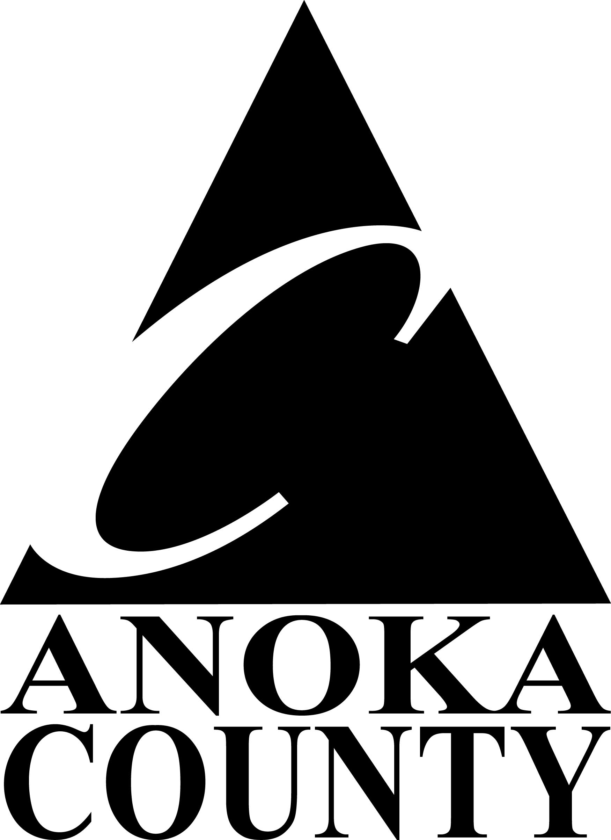
Anoka County Use Only
Date Rec’d

AC Project #
HUD Voucher #

Community Development Block Grant (CDBG)

Project and Planning

Disbursement Request Form
(Include required forms/documentation)

City/Agency: |  |  | Project Payment Requested for:
Payment Address:

Contact Information:  Name:  Title:  Phone: |  |  | Original  Grant Amount |  | Total  Previous Requests | Amount This Draw |  | New Balance

Accomplishment Data:
Low/Mod Area – Survey,  must be completed before funds will be disbursed |  | Low/Mod Public Facility –  Total number of Facility locations:
Low/Mod Area – Census Area,  must be completed before funds will be disbursed |  | Low/Mod Job Creation –  Total Number of Jobs created by business:  Total Number of Low/Mod income jobs created:
Slum/Blight Area,  must be completed before funds will be disbursed |  | Low/Mod Clientele –  Total Number of people served by project:  Total Number of Low/Mod People Served:
Slum/Blight Spot -  Total number of units addressed: |  | Low/Mod Housing –  Total Number of Housing Units in project:  Total Number of Low/Mod Housing Units:
Supporting Documentation for accomplishments and/or draw request must be attached.
Accomplishment Data must be on file at Anoka County to satisfy Federal Requirements. All projects that require prevailing wage will not receive a final draw until all requirements have been met.
Mail completed and signed requests to: Anoka County Community & Govt Relations 2100 3rd Avenue, STE 700  Anoka, MN 55303 | Questions, please contact:  Alice Strand 763-324-4616  Alice.Strand@AnokaCountyMn.gov | Date: | Signature:

“I certify to the best of my knowledge and belief that the information provided herein is true, complete, and accurate. I am aware that the provision of false, fictitious, or fraudulent information, or the omission of any material fact, may subject me to criminal, civil, or administrative consequences including, but not limited to violations of U.S. Code Title 18, Sections 2, 1001, 1343 and Title 31, Sections 3729-3730 and 3801-3812.”

