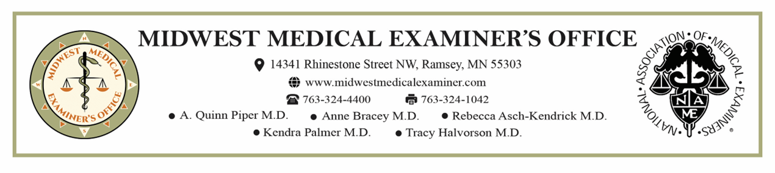

NEXT OF KIN AUTHORIZATION FOR REMOVAL

As the legal next of kin of ______________________________, who died _________, in _____________ County,
(Decedent’s name) (Date of death) (County of Death)

I, ______________________________, authorize _________________________________ to care for and remove
(NOK printed name) (Name of Funeral Home)

the above named decedent from the Midwest Medical Examiner’s Office for the purpose of funeral arrangements,

embalming, shipping, cremation, burial or other means of final disposition.

Signature: _____________________________________ Relationship to decedent: ______________________ (Next-of Kin) (Date)

This portion to be completed by the Funeral Home:

I, ______________________________with ___________________________________ received this
(Print name) (Name of Funeral Home)

completed authorization from the above named person on _______________at_______________.
(Date) (Time)

Signature of funeral home employee accepting this form _________________________________

**Please complete this form and leave it, at the time of removal,
along with any other necessary documentation

